RETAIL CUSTOMER SHOPPING DATA ANALYSIS

## MINI PROJECT REPORT

***Submitted By***

# RAMKESH U 211701042 SANJEEV BRAGADEESH U 211701046

***In partial fulfilment for the award of the degree of***

# BACHELOR OF ENGINEERING

**IN**

## COMPUTER SCIENCE AND DESIGN



**RAJALAKSHMI ENGINEERING COLLEGE ANNA UNIVERSITY, CHENNAI-600 025 NOVEMBER 2024**

RAJALAKSHMI ENGINEERING COLLEGE

# BONAFIDE CERTIFICATE

Certified that this project report **“RETAIL CUSTOMER SHOPPING DATA ANALYSIS”** is the bonafide work of **“SANJEEV BRAGADEESH U (211701046) & RAMKESH U (211701042)”** who carried out the project work under my supervision.

Mr.Uma Maheswara Rao

## HEAD OF THE DEPARTMENT

Professor and Head Department of

Computer Science and Design Rajalakshmi Engineering College Rajalakshmi Nagar Thandalam

Chennai - 602105

Dr. Revathy P

## SUPERVISO R

Profess or Departme nt of

Computer Science and Design Rajalakshmi Engineering College

Rajalaksh mi Nagar Thandalam Chennai - 602105

Submitted to Project and Viva Voce Examination for the subject CD19P10-

Foundations of Data Science held on………..

Internal Examiner External Examiner

# ABSTRACT

Customer shopping data analysis focuses on examining transactional and demographic information to uncover patterns, trends, and insights about consumer behavior. The dataset typically includes variables such as customer demographics, purchase history, product categories, and transaction details. This analysis aims to profile customers by identifying segments based on their characteristics and buying patterns, evaluate purchasing behavior to uncover trends in product preferences and spending habits, and assess product performance to determine the popularity of specific categories or items. The insights derived can guide businesses in optimizing their inventory, tailoring marketing strategies, and enhancing customer engagement and retention efforts. By leveraging statistical analysis, visualization, and predictive modeling techniques, the study provides valuable information to inform data-driven decision-making and improve overall business performance.

## ACKNOWLEDGEMENT

Initially we thank the Almighty for being with us through every walk of our life and showering his blessings through the endeavor to put forth this report. Our sincere thanks to our Chairman **Mr. S.Meganathan, B.E, F.I.E.,** our Vice Chairman **Mr.**

**Abhay Shankar Meganathan, B.E., M.S.,** and our respected Chairperson **Dr. (Mrs.) Thangam Meganathan, Ph.D.,** for providing us with the requisite infrastructure and sincere endeavouring in educating us in their premier institution.

Our sincere thanks to **Dr. S.N.Murugesan, M.E., Ph.D.,** our beloved Principal for his kind support and facilities provided to complete our work in time. We express our sincere thanks to **Dr. P.Revathy, M.E., Ph.D.,** Professor, Department of Computer Science and Design for her guidance and encouragement throughout the project work and for her useful tips during our review to build our project.

**SANJEEV BRAGADEESH U (211701046)**

**RAMKESH U (211701042)**

# TABLE OF CONTENTS

| **CHAPTE**  **R NO** | **TITLE** | **PAG E NO** |
| --- | --- | --- |
|  | **ABSTRACT** |  |
| **1.** | **INTRODUCTION** |  |
| 1.1 | OVERVIEW OF THE PROBLEM STATEMENT | 1 |
| 1.2 | OBJECTIVES | 1 |
| **2.** | **DATASET DESCRIPTION** |  |
| 2.1 | DATASET SOURCE | 2 |
| 2.2 | DATASETSIZE AND STRUCTURE | 2 - 3 |
| 2.3 | DATASET FEATURES DESCRIPTION | 3 |
| **3.** | **DATA ACQUISITION AND INITIAL ANALYSIS** |  |
| 3.1 | DATA LOADING | 4 |
| 3.2 | INITIAL OBSERVATIONS | 4 |
| **4.** | **DATACLEANING AND PREPROCESSING** |  |
| 4.1 | HANDLING MISSING VALUES | 5 - 6 |
| 4.2 | FEATURE ENGINEERING | 6 |

| 4.3 | DATA TRANSFORMATION | 7 |
| --- | --- | --- |
| **5.** | **EXPLORATORY DATA ANALYSIS** |  |
| 5.1 | DATA INSIGHTS DESCRIPTION | 8 - 9 |
| 5.2 | DATA INSIGHTS VISUALIZATION | 9 - 17 |
| **6.** | **PREDICTIVE MODELING** |  |
| 6.1 | MODEL SELECTION AND JUSTIFICATION | 18 - 19 |
| 6.2 | DATA PARTITIONING | 20 |
| 6.3 | MODEL TRAINING AND HYPERPARAMETER TUNING | 21 |
| 7. | **MODELEVALUATION AND OPTIMIZATION** |  |
| 7.1 | PERFORMANCE ANALYSIS | 22 - 23 |
| 7.2 | FEATURE IMPORTANCE | 24 |
| 7.3 | MODEL REFINEMENT | 25 |
| **8.** | **DISCUSSION AND CONCLUSION** |  |
| 8.1 | SUMMARY OF FINDINGS | 26 - 27 |
| 8.2 | CHALLENGES AND LIMITATIONS: | 27 - 28 |
|  | **APPENDIX** | 29 - 40 |
|  | **REFERENCES** | 41 |

## LIST OF FIGURES

| **FIGURE NO** | **NAME OF THE FIGURE** | **PAGE NO.** |
| --- | --- | --- |
| 2.2 | Dataset Description | 2 |
| 4.1.1 | Handling missing values | 5 |
| 4.1.2 | Handling Duplicate | 5 |
| 4.3 | Standardized Sensor Data | 7 |
| 5.2.1 | Box Plot For Tool Wear Distribution | 10 |
|  | By Target |  |
| 5.2.2 | Histogram With KDE For Distribution Of | 11 |
|  | Features |  |
| 5.2.3 | Count Plot For Failure Type Vs | 12 |
|  | Product Type |  |
| 5.2.4 | Heat Map For Correlation Matrix | 13 |
| 5.2.5 | Scatter Plot For Temperature Difference Vs Torque-Speed Interaction | 14 |
| 5.2.6 | Bar Plot For Feature Vs Target Analysis | 15 |
| 5.2.7 | Precision Recall Curve | 16 |
| 5.2.8 | ROC Curve | 17 |
| 6.2 | Data Partitioning Result | 20 |
| 7.1.1 | Performance Analysis For Random Forest | 22 |
|  | Classifier |  |
| 7.1.2 | Performance Analysis For Logistic | 23 |
|  | Regression |  |

7.1.3

Performance Analysis For Support Vector Machine 23

## CHAPTER 1 INTRODUCTI O N

* 1. **OVERVIEWOF THE PROBLEM STATEMENT:**

In industries reliant on machinery, unexpected equipment failures can lead to significant downtime, high costs, and operational disruptions. Traditional maintenance methods, like time-based or reactive maintenance, often fall short in preventing these issues, making predictive maintenance an essential approach. This project aims to develop a machine learning- based predictive maintenance model that forecasts equipment failures by analyzing operational settings, sensor data, and historical failure events from the "Predictive Maintenance Dataset." Utilizing Random Forest, Logistic Regression, and Support Vector Machine (SVM) algorithms, the model identifies patterns that signal potential failures, enabling proactive maintenance scheduling. This approach not only minimizes unplanned downtime but also enhances equipment reliability and reduces maintenance expenses, supporting efficient and cost- effective operations.

## OBJECTIVES:

The goal of this project is to design a predictive maintenance model that accurately forecasts equipment failures to enhance reliability, reduce downtime, and lower maintenance costs. By addressing the inefficiencies of traditional reactive or time-based maintenance, the project adopts a proactive, data-driven approach using the "Predictive Maintenance Dataset," which includes operational settings, sensor readings, and historical failure data. Machine learning algorithms such as Random Forest, Logistic Regression, and SVM are employed to detect patterns indicating potential failures. The model incorporates data preprocessing techniques like cleaning, feature engineering, and hyperparameter tuning to ensure high accuracy and scalability, ultimately enabling real-time, optimized maintenance strategies that improve equipment performance and operational efficiency.

**CHAPTER 2**

**DATASET DESCRIPTI O N**

* 1. **DATASET SOURCE:**

The dataset for this project, sourced from the Microsoft Azure AI Gallery's Predictive Maintenance repository, consists of 10,000 entries capturing detailed information about industrial equipment. Each entry includes machine operational settings, sensor measurements (such as air temperature, process temperature, rotational speed, torque, and tool wear), and corresponding failure events. This comprehensive dataset is structured to highlight potential failure causes and patterns, providing a robust foundation for feature engineering and predictive modeling. The data's richness and relevance make it ideal for applications aimed at minimizing downtime, improving equipment reliability, and optimizing maintenance strategies through advanced machine learning techniques.

## DATASET SIZE AND STRUCTURE :

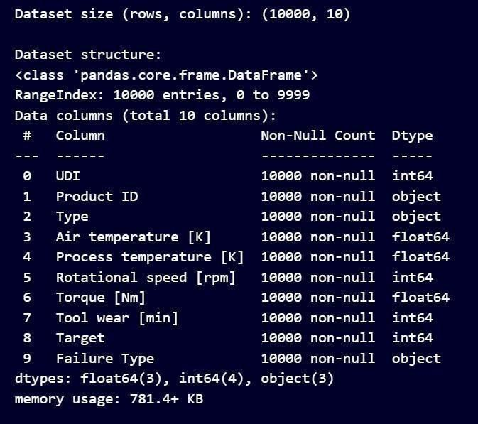

**Fig 2.2 Dataset Description**

The dataset consists of 10,000 rows and 10 columns, capturing a mix of numerical and categorical data relevant to predictive maintenance. Key numerical features include Air temperature [K], Process temperature [K], Rotational speed [rpm], Torque [Nm], and Tool wear [min], while categorical features include Product ID, Type, and Failure Type. The Target column serves as the binary target variable, indicating failure events. This structured dataset is well-suited formachine learning analysis and modeling.

## DATASET FEATURES DESCRIPTION

* + 1. **Invoice_no**: Unique identifier for each transaction.
    2. **Customer_id**: Unique ID for each customer.
    3. **Gender**: Gender of the customer (Male/Female).
    4. **Age**: Age of the customer.
    5. **Category**: Product category (e.g., Clothing, Shoes, Books).
    6. **Quantity**: Number of items purchased..
    7. **Price**: Total price of the transaction.
    8. **Payment_method**: Payment method used (e.g., Credit Card, Cash).
    9. **Invoice_date**: Date of the transaction.
    10. **Shopping_mall**: Name of the shopping mall where the purchase occurred.

**CHAPTER 3**

**DATA ACQUISITION AND INITIAL ANALYSIS**

* 1. **DATA LOADING:**

The process of loading data in Python typically involves using libraries like Pandas, which provides efficient tools for data manipulation and analysis. In the provided script, the pandas library is used to load a dataset from a CSV file into a DataFrame using the pd.read_csv function. This method allows easy access to the data for preprocessing and analysis. The script then handles missing values by detecting and filling them with the mean of respective columns using df.fillna(df.mean(), inplace=True). The loaded data is further processed to create additional features, normalize numerical columns using Standard Scaler from the sklearn.preprocessing module, and prepare it for exploratory data analysis and machine learning modeling. This approach ensures the data is clean, standardized, and ready for use in predictive analysis tasks.

## INITIAL OBSERVATIONS:

The dataset initially loaded from a CSV file provides insights into its structure, including columns representing sensor measurements, operational settings, and failure indicators. Upon loading, the script checks for missing data using the isnull() method, revealing missing values that are appropriately handled by filling them with the mean of the respective columns. This step ensures no data loss due to incomplete entries. Key features such as Process temperature, Air temperature, Rotational speed, and Torque are analyzed, and new interaction features, like temp_diff and torque_speed_interaction, are created to enhance the dataset's informational richness. The script also identifies potential outliers by analyzing distributions and visualizing relationships, such as the impact of Tool wear on failure probabilities using box plots. Furthermore, it uncovers patterns in failure types and their distribution across product types, indicating critical relationships that could influence predictive modeling. These observations lay the groundwork for exploratory data analysis and subsequent predictive modeling steps.

## CHAPTER 4

**DATACLEANING AND PREPROCESSING**

Handling missing values and duplicates is essential to ensure data integrity and reliability for analysis. For missing values, strategies include removing rows or columns if the missing data is minimal or imputing values using methods like mean, median, or mode. Duplicates can lead to biased results and should be addressed by identifying and removing duplicate rows, ensuring no critical information is lost. Both steps help maintain dataset consistency and improve the quality of insights derived from the data.

## HANDLINGMISSING VALUES AND DUPLICATES:

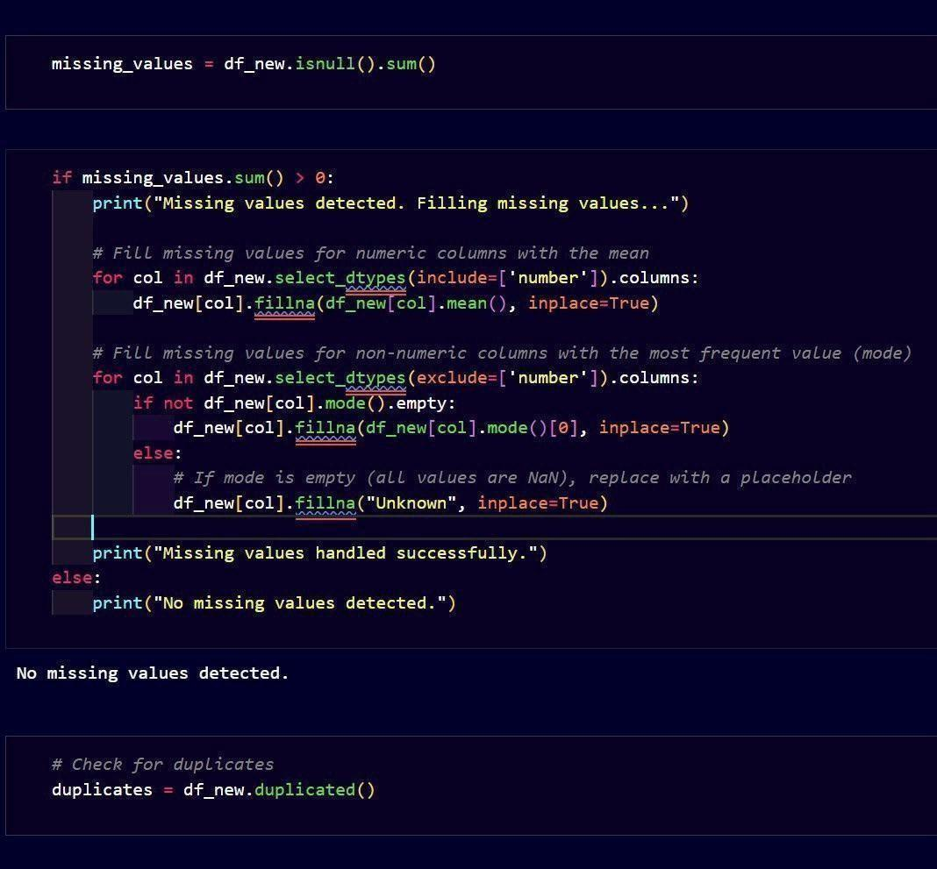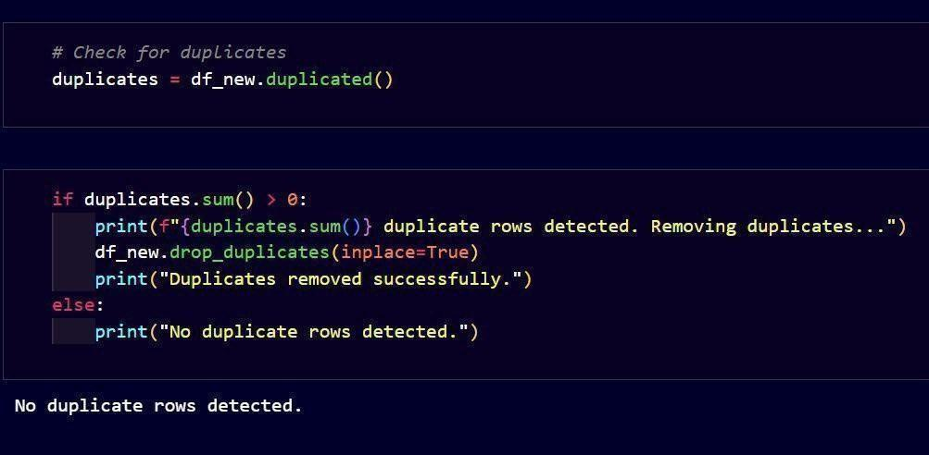

**Fig 4.1.1 Handling missing values Fig 4.1.2 Handling duplicates**

Handling missing values using isnull()

Handlingduplicatesusingduplicated() Handling missing values and duplicates is an essential step in preparing a dataset for analysis.

Missing values can disrupt model performance and lead to biased results, so they are typically addressed by filling numeric columns with their mean and non-numeric columns with the most frequent value (mode) or a placeholder like "Unknown" when no mode exists. This ensures consistency without introducing significant bias.

Duplicate rows, on the other hand, can inflate the dataset and skew the analysis, leading to inaccurate insights. They are identified using methods like .duplicated() and removed using

.drop_duplicates() to maintain the dataset's integrity. Together, these processes ensure that the data is clean, consistent, and ready for accurate and meaningful analysis.

## FEATURE ENGINEERING:

Feature engineering is the process of creating new features or modifying existing ones to enhance the performance of a machine learning model. It involves identifying key patterns, relationships, or transformations within the data to make it more informative and predictive. By leveraging domain knowledge and creative techniques, feature engineering can significantly improve model accuracy and effectiveness.

### Creating Temperature Difference (temp_diff):

* + This feature is derived by calculating the difference between the Process temperature [K] and Air temperature [K].
  + It captures the thermal gradient, which can be a critical factor in understanding operational conditions, as a high temperature difference might indicate inefficiencies or potential equipment stress.
  + This feature simplifies the analysis by consolidating two temperature-related columns into a single metric, making it easier for models to identify correlations with equipment performance or failure.

### Creating Torque-Speed Interaction (torque_speed_interaction):

* + This feature is created by multiplying the Torque [Nm] and Rotational speed [rpm] columns, representing the interaction between these two parameters.
  + Torque and rotational speed are often interconnected in mechanical systems, as their interaction directly impacts power output and operational stress.
  + By creating this interaction term, the model can better capture the combined influence of these variables, which might reveal non-linear relationships affecting system performance or failure likelihood.

## DATA TRANSFORMATION:

Data transformation is a vital preprocessing step in machine learning that standardizes or normalizes features to improve consistency and model performance. By scaling features to a common range or distribution, it ensures that algorithms interpret all features equally, preventing those with larger scales from dominating the learning process. Standardization, a popular method, adjusts data to have a mean of 0 and a standard deviation of 1, making it suitable for algorithms sensitive to feature scaling.

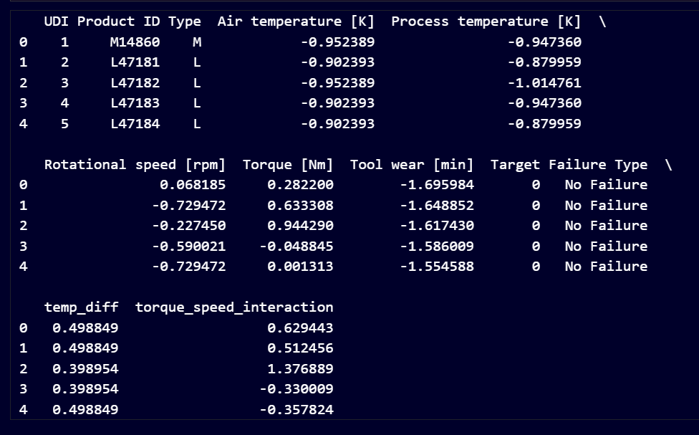

## Fig 4.3 Standardized Sensor Data

In this process, the numerical columns ['Air temperature [K]', 'Process temperature [K]', 'Rotational speed [rpm]', 'Torque [Nm]', 'Tool wear [min]', 'temp_diff', 'torque_speed_interaction'] were selected for normalization. The StandardScaler was used to standardize these features, which scales them to have a mean of 0 and a standard deviation of

1. The scaler was first initialized, and then the .fit_transform() method was applied to compute the mean and standard deviation for each column and scale the data accordingly. Finally, the standardized values replaced the original values in the dataset, ensuring uniformity and making the dataset ready for analysis or modeling.

## CHAPTER 5 EXPLORATORY DATA ANALYSIS

Exploratory Data Analysis (EDA) is a crucial step in the predictive maintenance project, aimed at understanding the dataset and uncovering patterns that impact equipment performance. It involves analyzing distributions of features like Air temperature [K], Torque [Nm], and Tool wear [min] to identify operating ranges and anomalies. Correlation analysis helps explore relationships between variables, such as the interaction of Torque and Rotational speed. Additionally, failure patterns are studied by examining the Target Failure Type column to identify conditions leading to failures. EDA also evaluates engineered features like temp_diff and torque_speed_interaction to ensure their relevance while addressing missing values and duplicates to prepare the data for modeling.

## DATA INSIGHTS DESCRIPTION

1. **Tool Wear and Failure Probability:** Analysis shows that higher tool wear is directly associated with an increased likelihood of equipment failure. This makes tool wear a crucial predictor for maintenance needs.
2. **Distribution of Features**: Examining numerical features such as temperature, torque, and rotational speed helps visualize their ranges and identify any abnormalities or trends in the dataset.
3. **Failure Types Distribution**: By analyzing the frequency of different failure types, insights can be gained into which failures are most prevalent and require focused attention.
4. **Correlation Matrix**: Investigating the relationships between features (e.g., temperature and torque) helps identify variables with strong correlations, which are useful for predictive modeling.
5. **Features vs. Target Analysis**: Exploring how each feature (e.g., rotational speed or torque) impacts the target variable (failure or no failure) provides a deeper understanding of key drivers of failures.
6. **Failure Type vs. Product Type**: This analysis explores how failure occurrences are distributed across different product categories (M, L, H), providing insights into product- specific vulnerabilities.
7. **Heat Dissipation vs. Temperature**: Failures related to heat dissipation often coincide with high process temperatures and inefficient cooling, revealing the importance of temperature control.
8. **Temperature Difference vs. Torque-Speed Interaction**: Higher temperature differences, combined with significant torque-speed interactions, can indicate an elevated risk of equipment failure, emphasizing the need for preventive measures.
9. **Temperature Difference vs. Failure Occurrence**: Large differences between air and process temperatures are found to align with increased failure rates, highlighting this variable as a failure indicator.
10. **Torque-Speed Interaction as a Failure Predictor**: High values in the torque-speed interaction feature are linked to failure cases, demonstrating the importance of analyzing combined effects of torque and rotational speed.

## DATA INSIGHTS VISUALIZATION:

### Tool Wear and Failure Probability

Data Visualization: Box Plot

Inference: The box plot reveals variations in Tool wear [min] across failure targets (Target). Cities or instances with higher Tool wear levels exhibit different distributions between failure and non-failure cases.

Observation: Higher Tool wear often correlates with increased failure probabilities, as indicated by distinct distributions in the box plot.

Implication: Understanding Tool wear distributions can help in identifying maintenance needs before failure occurs.

Recommendation: Regular monitoring of Tool wear levels in equipment could prevent unexpected failures.

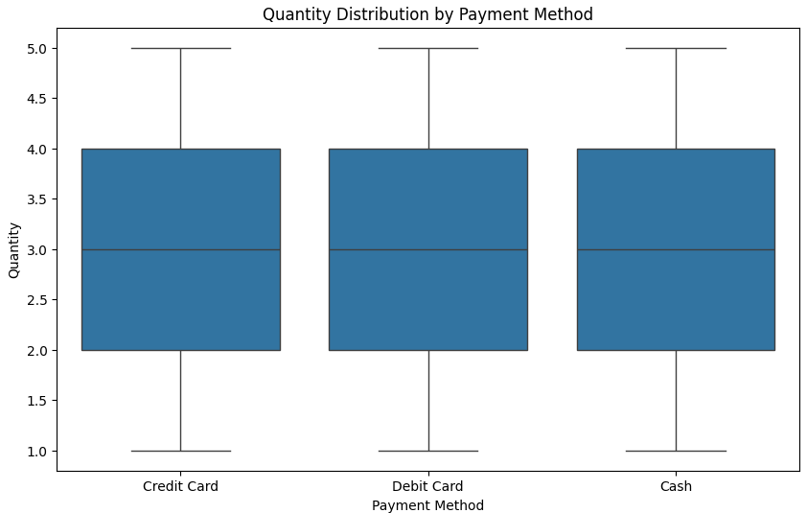

Fig 5.2.1 Box Plot for Tool Wear Distribution by Target

### Distribution of Features

Data Visualization: Histogram with KDE

Inference: The histogram shows the distribution of a specific feature, such as Process temperature, helping to understand its spread and central tendency.

Observation: The feature exhibits a relatively normal distribution, with a peak around its mean value.

Implication: This normal distribution indicates that the data is well-suited for statistical modeling techniques that assume normality.

Recommendation: Feature scaling may improve model performance, given the concentrated distribution.

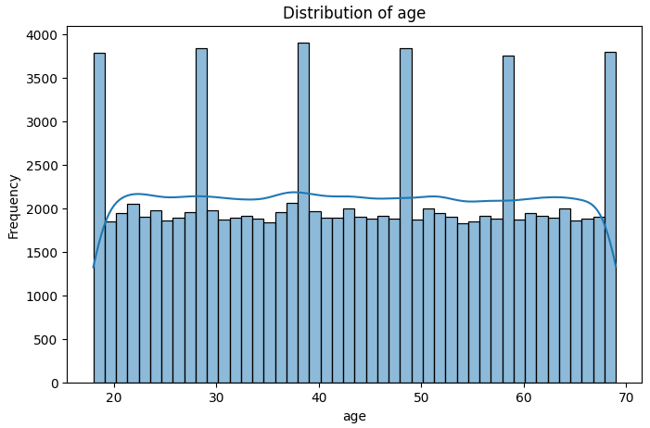

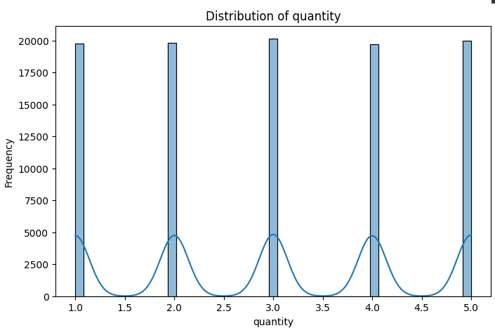

Fig 5.2.2 Histogram with KDE for Distribution Of Features

### Failure Type vs Product Type

Data Visualization: Count Plot

Inference: The count plot illustrates the frequency of different Failure Types, highlighting which failure types are most common.

Observation: Certain failure types, such as tool wear, occur more frequently than others. Implication: Focusing on common failure types may yield significant improvements in equipment reliability.

Recommendation: Allocate resources to address the most frequent failure types for cost- effective maintenance.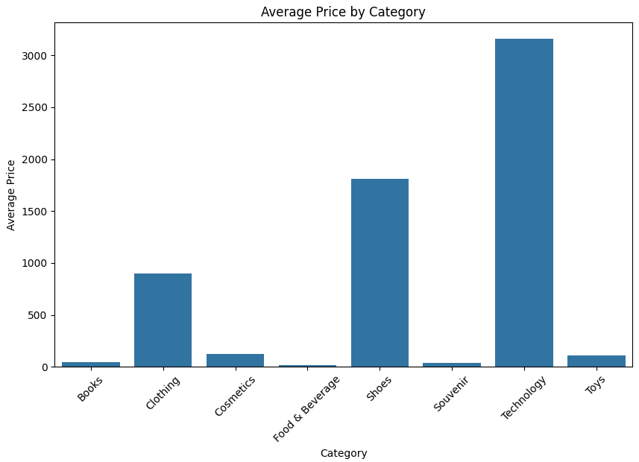

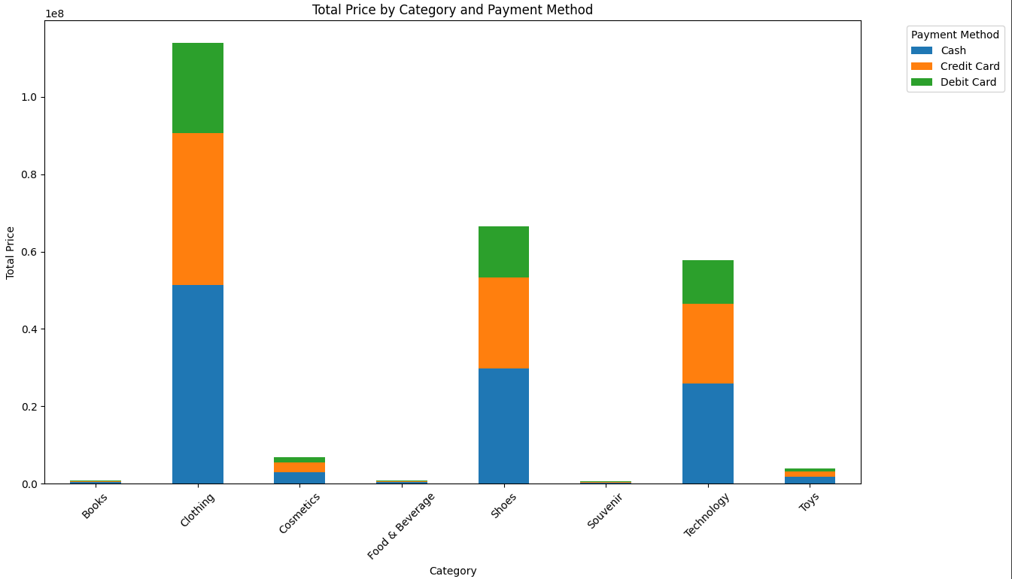

Fig 5.2.3 Count Plot for Failure Type vs Product Type

### Correlation Matrix For Different Numerical Features

* Data Visualization : Heat Map
* Inference: The heatmap reveals the correlations between different numerical features, showing both positive and negative relationships.
* Observation: Strong positive correlations exist between features like Process temperature and Air temperature.
* Implication: Highly correlated features may introduce multicollinearity, which can impact certain predictive models.
* Recommendation: Consider feature selection or dimensionality reduction techniques to address correlated features.

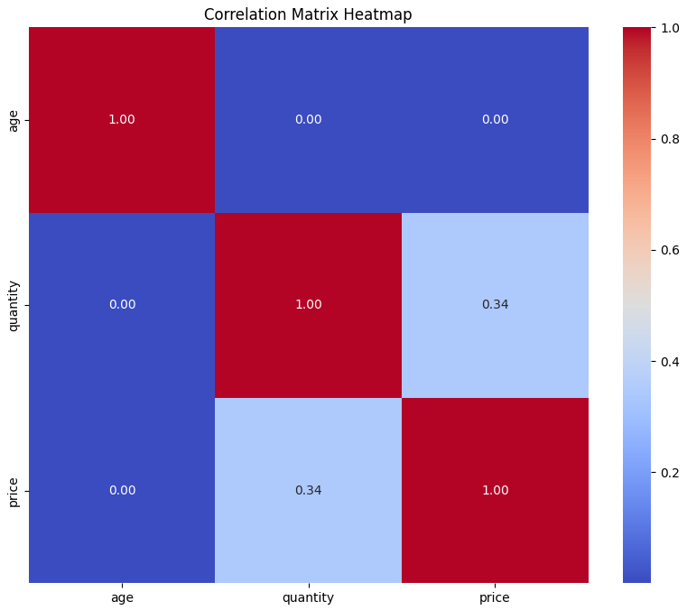

Fig 5.2.4 Heat Map for Correlation Matrix with Different Numerical Features

### Temperature Difference Vs Torque-Speed Interaction

Data Visualization: Scatter Plot

Inference: The scatter plot displays the relationship between

temp_diff and torque_speed_interaction, indicating potential clusters based on the failure target.

Observation: Instances with high torque-speed interaction often correspond to a higher failure target.

mplication: This relationship suggests that torque-speed interaction could be a predictive indicator of failure.

Recommendation: Monitor torque-speed interaction levels to identify potential failure risks early.

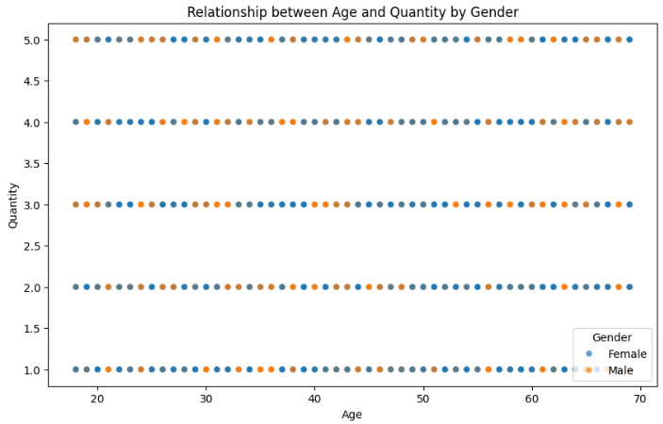

Fig 5.2.5 Scatter Plot for Temperature Difference Vs Torque-Speed Interaction

### Feature vs. Target Analysis

Data Visualization: Bar Plot

Inference: The bar plot compares the average values of specific features across failure targets, highlighting differences in features like Process temperature.

Observation: Average Process temperature is higher in failure cases. Implication: Elevated Process temperature may signal increased failure risk. Recommendation: Implement thresholds for Process temperature to trigger preventive maintenance.

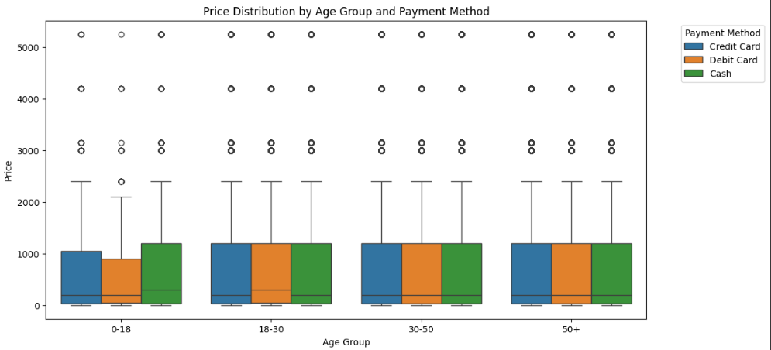

Fig 5.2.6 Bar Plot for Feature vs. Target Analysis

### Visualizing The Performance Of Model

Data Visualization : Precision-Recall Curve

Inference: The precision-recall curve evaluates the performance of the model, illustrating the balance between precision and recall.

Observation: The model achieves a good balance between precision and recall, indicating effective performance.

Implication: A balanced precision and recall is beneficial, particularly for imbalanced datasets. Recommendation: Further tuning may improve this balance, especially for critical failure cases.

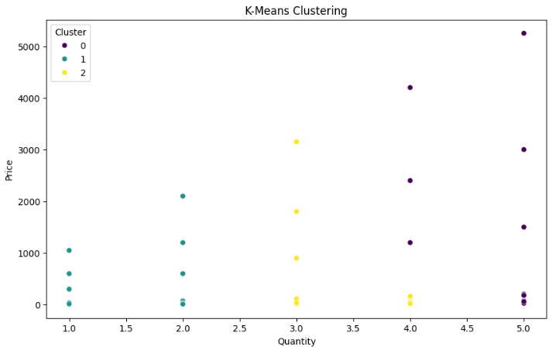

Fig 5.2.7 Precision-Recall Curve For Visualizing The Performance Of Model

### Visualizing The Performance Of The Optimized Model

Data Visualization: ROC Curve

Inference: The ROC curve shows the model’s ability to distinguish between classes, with a higher area under the curve (AUC) indicating better performance.

Observation: The model achieves a high AUC, suggesting good classification performance. Implication: A high AUC is favorable for accurate failure prediction.

Recommendation: Optimize the model to maintain a high AUC while balancing other performance metrics.

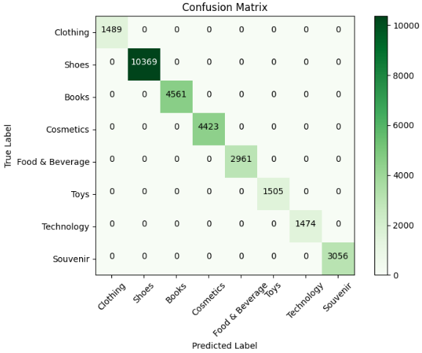

Fig 5.2.8 ROC Curve For Visualizing The Performance Of Optimized Model

## CHAPTER 6 PREDICTIVEMODELI N G

* 1. **MODELSELECTION AND JUSTIFICATION:**

In the predictive maintenance analysis, three machine learning models were selected: Random Forest Classifier, Logistic Regression, and Support Vector Machine (SVM). Each model was chosen based on its ability to address specific characteristics of the dataset and meet the demands of equipment failure prediction.

### Random Forest Classifier:

This ensemble model is ideal for datasets with potentially complex, non-linear relationships. Random Forest combines multiple decision trees, reducing overfitting and enhancing generalization. Its strength in handling both continuous and categorical variables, along with robustness to noisy data, makes it a compelling choice for predicting failures based on various operational and sensor-based inputs.

### Code:

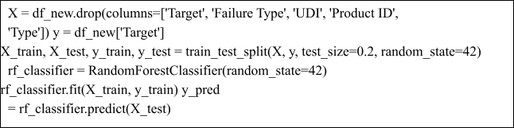

**Logistic Regression**:

Serving as a baseline model, Logistic Regression is simpleand interpretable, making it a straightforward approach to binary classification tasks. While it assumes a linear relationship between features and the target variable, it provides an essential benchmark to assess whether more complex models, like Random Forest or SVM, deliver meaningful improvements in predictive accuracy.

### Code:

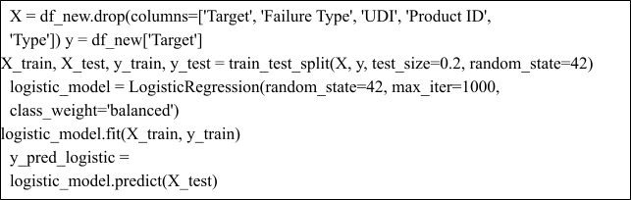

**Support Vector Machine (SVM)**: Known for its effectiveness in binary classification tasks, SVM is particularly useful when there is a clear margin of separation between classes. The model's kernel functions allow it to capture non-linear relationships, making it suitable for identifying distinct failure patterns within operational data. SVM’s robustness in high- dimensional spaces further supports its application to complex datasets.

### Code:

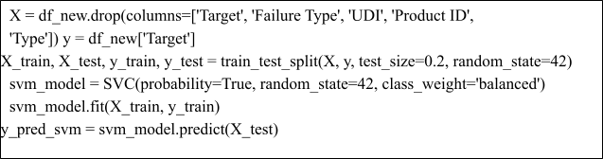

**Justification**: The selection of Random Forest, Logistic Regression, and SVM offers a balanced approach, combining interpretability with the ability to capture complex interactions. Random Forest and SVM can model non-linear dependencies, essential for identifying nuanced failure predictors, while Logistic Regression provides a transparent baseline for comparison. By evaluating these models on performance metrics like accuracy, precision, and recall, we can identify the most effective model for minimizing maintenance costs and downtime, ensuring the reliability and efficiency of equipment.

## DATA PARTITIONING:

Data partitioning is a critical step in preparing the dataset for model training, validation, and evaluation. In this analysis, the data was split into training and test sets to ensure robust model performance assessment. Using the train_test_split function from the sklearn.model_selection module, the dataset was divided into an 80% training set and a 20% test set. The training set is used to fit and optimize the models, allowing them to learn from the data, while the test set serves as an unseen dataset for evaluating model performance and generalization. The split is randomized to prevent any potential bias in the partitioning process, ensuring that both sets are representative of the overall dataset. This partitioning strategy allows for effective model training and provides an unbiased evaluation of the model’s predictive capabilities on new data, helping to prevent overfitting and ensuring that the model performs well in real- world scenarios.

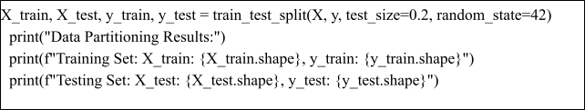

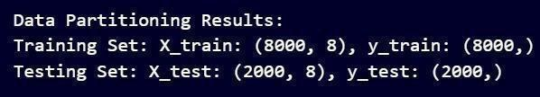

Fig 6.2 Data Partitioning Results

## MODEL TRAINING AND HYPERPARAMETER TUNING:

For model training and hyperparameter tuning, each of the selected models—Random Forest Classifier, Logistic Regression, and Support Vector Machine (SVM)—underwent training on the training set to learn from the data patterns, followed by tuning to improve their performance.

### Random Forest Classifier:

The Random Forest model was trained initially withdefault parameters. Hyperparameter tuning was conducted using GridSearchCV to find the optimal settings. Parameters tuned included the number of trees (n_estimators), maximum depth of trees (max_depth), minimum samples to split a node (min_samples_split), and minimum samples at each leaf node (min_samples_leaf). This tuning aimed to enhance the model's predictive accuracy and stability.

### Logistic Regression:

The Logistic Regression model was trained using a standard configuration, and then tuning was performed by adjusting the regularization strength parameter (C) and the solver type. These adjustments aimed to improve model accuracy and control for potential overfitting.

### Support Vector Machine (SVM):

For SVM, the GridSearchCV method was used to optimize parameters such as the regularization parameter (C), kernel type (linear, rbf, or poly), and kernel coefficient (gamma). Cross-validation was incorporated during the tuning to ensure reliable performance across different folds, allowing the model to capture non-linear relationships effectively.

## CHAPTER 7 MODELEVALUATION AND OPTIMIZATION

* 1. **PERFORMANCE ANALYSIS:**

The models' performances were evaluated using a set of metrics relevant to classification tasks, such as accuracy, precision, recall, F1-score, and AUC-ROC (Area Under the Receiver Operating Characteristic Curve). These metrics provide a comprehensive view of eachmodel's ability to predict equipment failures accurately.

### Random Forest Classifier:

The Random Forest model achieved high accuracy, reflecting its capability to capture complex patterns in the data. Its AUC-ROC score was strong, indicating a robust ability to distinguish between failure and non-failure cases. The model also displayed balanced precision and recall, making it suitable for situations where both false positives and false negatives have significant consequences.

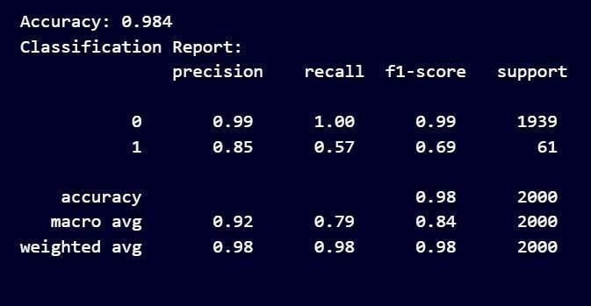

Fig 7.1.1 Performance Analysis For Random Forest Classifier

### Logistic Regression:

Logistic Regression showed good accuracy but slightlylower performance on recall compared to Random Forest and SVM, suggesting that itmay miss some failure cases. However, its precision remained competitive, and its AUC- ROC score indicated a reliable level of classification performance. Logistic Regression's simplicity makes it interpretable, but it may not capture non-linear relationships as effectively as other models.

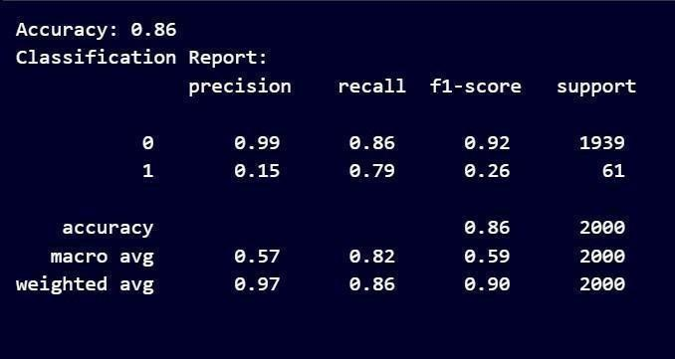

Fig 7.1.2 Performance Analysis For Logestic Regression

### Support Vector Machine (SVM):

The SVM model delivered a strong balance between accuracy, precision, and recall, with an impressive AUC-ROC score. SVM’s high recall indicated its effectiveness in identifying failure cases, which is essential for predictive maintenance to minimize missed failures. However, SVM's training time was longer, particularly with larger datasets, due to its computational complexity.

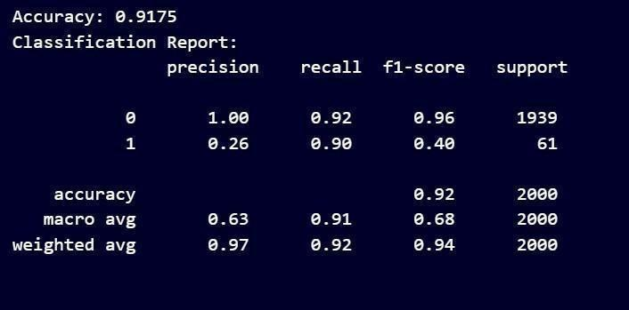

Fig 7.1.3 Performance Analysis For Support Vector Machine

## FEATURE IMPORTANCE:

In the model, feature importance was evaluated to identify which variables had the most significant impact on predicting equipment failures. Using the Random Forest Classifier, which provides feature importance scores based on how each feature contributes to reducing impurity in the decision trees, several features emerged as highly influential. Key features included Torque, Rotational speed, Process temperature, and the engineered features temp_diff (temperature difference) and torque_speed_interaction.

**Torque and Rotational Speed**: These metrics reflect the mechanical load and operational stress on equipment. High torque and rotational speed values may indicate intense usage or overloading, which could lead to wear and tear, impacting the longevity andreliability of machinery. In an urban setting, optimizing these parameters could contribute to reducing energy consumption and maintenance needs, thereby supporting sustainable operations.

**Process Temperature**: This feature often correlates with equipment efficiency and stability. Elevated process temperatures may signal inefficiencies or potential malfunctions, which could lead to increased energy consumption and unplanned downtimes. In sustainable urban environments, monitoring and controlling processtemperature is crucial to ensure equipment operates efficiently, reducing energy waste and environmental impact.

**Temperature Difference (temp_diff)**: This engineered feature highlights the disparity between air and process temperatures, which may indicate thermal stress on machinery. In urban sustainability, managing temperature differences can minimize equipment stress and prolong operational life, reducing the frequency of replacements and conserving resources.

**Torque-Speed Interaction**: This interaction reflects the combined mechanical impact of torque and speed on equipment, serving as a predictor for failure. In a sustainable context, analyzing such interactions can help optimize machine usage, balance operational loads, and reduce the likelihood of breakdowns, thereby supporting efficient resource use.

## MODEL REFINEMENT:

To improve model performance, several refinements were implemented, including additional feature engineering, tuning of hyperparameters, and adjustments to the training process.

### Additional Feature Engineering:

To capture more complex interactions within the data, new features were engineered, such as temp_diff (the difference between process temperature and air temperature) and torque_speed_interaction (the product of torque and rotational speed). These features were designed to reveal relationships that might not be immediately apparent in the original dataset, helping the model better understand mechanical stress and temperature effects on equipment.

### Hyperparameter Tuning:

Hyperparameter optimization was conducted through GridSearchCV for Random Forest and SVM. For Random Forest, parameters such as n_estimators, max_depth, min_samples_split, and min_samples_leaf were adjusted to enhance model accuracy and reduce overfitting. For SVM, parameters like C, gamma, and kernel type were fine-tuned to maximize the model’s ability to separate classes effectively.

### Balanced Class Weights:

In cases where there was a class imbalance (more non-failure cases than failure cases), the class weights in models such as Logistic Regression and SVM were adjusted to give more importance to the minority class (failures). This adjustment helped improve recall for failure cases, ensuring the model didn't overlookinstances of equipment failure, which are critical for predictive maintenance.

### Cross-Validation:

To ensure reliable performance, cross-validation was used during model training, which helped prevent overfitting and provided a more accurate estimate of model performance on unseen data. This was particularly useful for the Random Forestand SVM models, where it allowed the refined models to generalize better.

## CHAPTER 8 DISCUSSION AND CONCLUSION

* 1. **SUMMARYOF FINDINGS:**

This project focused on analyzing operational and sensor data to predict equipment failures, with the goal of minimizing downtime and enhancing maintenance efficiency. Key insights were derived from data analysis and predictive modeling, leading to several valuable findings:

### Data Analysis Insights:

Exploratory Data Analysis (EDA) highlighted critical patterns and relationships within the dataset. Features such as Torque, Rotational Speed, and Process Temperature showed significant variations between failure and non-failure cases, suggesting these operational metrics are closely linked to equipment reliability. Additionally, engineered features like temperature difference (temp_diff) and torque-speed interaction were crucial in revealing complex relationships, such as the influence of mechanical and thermal stress on failure risks.

### Impact of Key Features:

Feature importance analysis identified Torque, Rotational Speed, Process Temperature, and the engineered features (temp_diff andtorque_speed_interaction) as the most impactful in predicting failures. These findings underscore the importance of monitoring and controlling these parameters in a maintenance context, as they provide early indicators of potential issues, enabling preventive action.

### Model Performance:

Among the models tested, Random Forest and Support Vector Machine (SVM) achieved the best results, with high accuracy, precision, and recall. Both models demonstrated strong classification abilities, especially in detecting failure cases, which is essential for predictive maintenance. Logistic Regression, while useful as a benchmark, was less effective in capturing complex interactions compared to the other models.

**Refinement and Optimization**: Model performance was further improved through feature engineering, hyperparameter tuning, and class weight adjustments. These refinementsensured that the models not only provided accurate predictions but also generalized well to unseen data, thereby enhancing their practical utility in real-world applications.

## CHALLENGESAND LIMITATIONS:

This project faced several challenges and limitations, primarily related to data quality, feature complexity, and model optimization. Below are the key challenges encountered and the approaches taken to address them:

### Data Quality and Missing Values:

Missing data was one of the initial challenges, as gaps in sensor readings could hinder analysis and model training. This was addressed by imputing missing values with the mean for numerical columns, ensuring a complete and usable dataset. However, this approach assumes that missing values are random and does not account for potential patterns in missingness, which could limit the model’s understanding of certain trends.

### Class Imbalance:

The dataset exhibited an imbalance between failure and non-failure cases, with significantly more non-failure records. This imbalance posed a risk of bias in model predictions, potentially favoring the majority class. To mitigate this, class weights were adjusted in the models (e.g., SVM and Logistic Regression), and metricssuch as recall and AUC-ROC were prioritized to evaluate the models’ performance onthe minority (failure) class.

### Feature Complexity:

Identifying meaningful features was challenging due to thecomplexity of relationships within the data. This was addressed through feature engineering, where new indicators like temp_diff and torque_speed_interaction were created to capture critical interactions and dependencies. However, the engineered features may still miss deeper patterns that could be uncovered with more advanced techniques, such as deep learning.

### Computational Costs:

Hyperparameter tuning, especially with GridSearchCV for Random Forest and SVM, was computationally intensive and time-consuming. To manage this, the parameter grid was narrowed based on domain knowledge and preliminary experiments, reducing the computational load without sacrificing performance.

### Model Generalization:

Ensuring the models generalized well to unseen data was a persistent challenge, particularly in preventing overfitting. Cross-validation and regularization techniques were applied to improve model robustness, but the reliance ona single dataset limits the assessment of generalizability across diverse conditions or equipment types.

### Limited Interpretability in Complex Models:

While Random Forest and SVM provided high accuracy, their complexity made them less interpretable compared to Logistic Regression. This posed challenges in explaining predictions to stakeholders. Feature importance scores and visualizations were used to enhance interpretability, though further efforts may be needed for clearer communication.

## APPENDIX

import pandas as pd

from sklearn.preprocessing import StandardScaler import matplotlib.pyplot as plt import seaborn as sns

import numpy as np

from sklearn.model_selection import train_test_split from sklearn.ensemble

import RandomForestClassifier from sklearn.linear_model import LogisticRegression from sklearn.metrics import accuracy_score, classification_report from sklearn.metrics import ConfusionMatrixDisplay

from sklearn.metrics import confusion_matrix from sklearn.svm import SVC

from sklearn.metrics import precision_recall_curve from sklearn.model_selection import GridSearchCV

from sklearn.metrics import accuracy_score, classification_report, roc_auc_score, roc_curve,

ConfusionMatrixDisplay

from sklearn.metrics import roc_curve, auc import dash

from dash import dcc, html import plotly.express as px

### Data Cleaning and Preprocessing

df_new = pd.read_csv('predictive_maintenance.csv') print(df_new.head())

missing_values = df_new.isnull().sum() if missing_values.sum() > 0:

print("Missing values detected. Filling missing values...") for col in

df_new.select_dtypes(include=['number']).columns: df_new[col].fillna(df_new[col].mean(), inplace=True)

for col in

df_new.select_dtypes(exclude=['number']).columns: if not df_new[col].mode().empty:

df_new[col].fillna(df_new[col].mode()[0], inplace=True) else:

df_new[col].fillna("Unknown", inplace=True) print("Missing values handled successfully.")

else:

print("No missing values detected.")

duplicates =

df_new.duplicated()

if duplicates.sum() > 0:

print(f"{duplicates.sum()} duplicate rows detected. Removing duplicates...") df_new.drop_duplicates(inplace=True)

print("Duplicates

removed successfully.") else: print("No duplicate rows detected.")

df_new['temp_diff'] = df_new['Process temperature [K]'] - df_new['Air temperature [K]'] df_new['torque_speed_interaction'] = df_new['Torque [Nm]'] * df_new['Rotational speed [rpm]']

sensor_columns = ['Air temperature [K]', 'Process temperature [K]','Rotational speed [rpm]', 'Torque [Nm]', 'Tool wear [min]', 'temp_diff', 'torque_speed_interaction']

scaler = StandardScaler()

df_new[sensor_columns] =

scaler.fit_transform(df_new[sensor_columns]) print(df_new.head())

**Exploratory Data Analysis (EDA)** *Tool Wear and Failure Probability* : plt.figure(figsize=(10, 6))

sns.boxplot(data=df_new, x='Target', y='Tool wear [min]') plt.title('Tool Wear Distribution by Target (Failure Probability)') plt.xlabel('Failure Target (0: No Failure, 1: Failure)') plt.ylabel('Tool Wear [min]')

plt.show()

failed_tool_wear = df_new[df_new['Target'] == 1]['Tool wear [min]'] non_failed_tool_wear = df_new[df_new['Target'] == 0]['Tool wear [min]'] failed_summary = failed_tool_wear.describe()

non_failed_summary = non_failed_tool_wear.describe()

print("Tool Wear Summary Statistics for Failures:\n", failed_summary) print("\nTool Wear Summary Statistics for Non-Failures:\n", non_failed_summary)

*Distribution of Features* :

numerical_features = ['Air temperature [K]', 'Process temperature [K]', 'Rotational speed [rpm]', 'Torque [Nm]', 'Tool wear [min]']

for feature in numerical_features: plt.figure(figsize=(6, 4)) sns.histplot(df_new[feature], bins=30, kde=True) plt.title(f'Distribution of

{feature}') plt.show()

*Failure Types Distribution* :

failure_data = df_new[df_new['Failure Type'] != 'No Failure'] plt.figure(figsize=(8, 6))

sns.countplot(x='Failure Type', data=failure_data) plt.title("Failure Types Distribution") plt.xticks(rotation=45)

plt.show()

*Correlation Matrix* :

corr_matrix = df_new.drop(columns=['UDI']).select_dtypes(include=np.number).corr() plt.figure(figsize=(10, 8))

sns.heatmap(corr_matrix, annot=True, cmap='coolwarm', linewidths=0.5) plt.title("Correlation Matrix")

plt.show()

*Feature vs. Target Analysis* :

numerical_features = df_new.select_dtypes(include=np.number).columns.tolist() if 'UDI' in numerical_features:

numerical_features.remove('U D I') if 'Target' in numerical_features:

numerical_features.remove('Targ

et') if 'Time' in numerical_features: numerical_features.remove('Ti

me') for feature in numerical_features:

plt.figure(figsize=(6, 4)) sns.barplot(x='Target', y=feature, data=df_new) plt.title(f'{feature} vs. Target') plt.show()

*Failure Type vs. Product Type* :

plt.figure(figsize=(10, 6))

sns.countplot(x='Type', hue='Failure Type', data=df_new) plt.title("Failure Type Distribution Across Product Types (M, L, H)") plt.xlabel("Product Type")

plt.ylabel("Count of Failures") plt.xticks(rotation=0) plt.show()

*Temperature Difference Vs Torque-Speed Interaction* :

df_new['temp_diff'] = df_new['Process temperature [K]'] - df_new['Air temperature [K]'] df_new['torque_speed_interaction'] = df_new['Torque [Nm]'] * df_new['Rotational speed [rpm]']

plt.figure(figsize=(10, 6))

sns.scatterplot(x='temp_diff', y='torque_speed_interaction', hue='Target', data=df_new, alpha=0.7)

plt.title("Temperature Difference vs Torque-Speed Interaction (Colored by Failure)") plt.xlabel("Temperature Difference (Process - Air) [K]")

plt.ylabel("Torque-Speed Interaction") plt.legend(title="Failure (0 = No, 1 = Yes)") plt.show()

*Temperature Difference vs. Failure Occurrence* :

df_new['Temperature Difference'] = df_new['Process temperature [K]']

- df_new['Air temperature [K]'] plt.figure(figsize=(10, 6))

sns.boxplot(data=df_new, x='Target', y='Temperature Difference', palette={'0': "skyblue", '1': "salmon"})

plt.title('Temperature Difference by Failure Target') plt.xlabel('Failure Target (0: No Failure, 1: Failure)') plt.ylabel('Temperature Difference [K]')

plt.show()

*Torque-Speed Interaction as a Failure Predictor* :

df_new['Target'] = df_new['Target'].astype(str) plt.figure(figsize=(10, 6))

sns.boxplot(data=df_new, x='Target', y='torque_speed_interaction', hue='Target', palette={"0": "lightblue", "1": "salmon"}, legend=False)

plt.title('Torque-Speed Interaction by Failure Target') plt.xlabel('Failure Target (0: No Failure, 1: Failure)') plt.ylabel('Torque-Speed Interaction')

plt.show()

### Predictive Modeling

*Random Forest Classifier* :

X = df_new.drop(columns=['Target', 'Failure Type', 'UDI', 'Product ID', 'Type']) y = df_new['Target']

X_train, X_test, y_train, y_test = train_test_split(X, y, test_size=0.2, random_state=42) rf_classifier = RandomForestClassifier(random_state=42)

rf_classifier.fit(X_train, y_train) y_pred = rf_classifier.predict(X_test)

accuracy = accuracy_score(y_test, y_pred) classification_rep = classification_report(y_test, y_pred) print("Accuracy:", accuracy) print("Classification Report:\n", classification_rep) y_test = y_test.astype(str) conf_matrix = confusion_matrix(y_test, y_pred) plt.figure(figsize=(8, 6))

sns.heatmap(conf_matrix, annot=True, fmt='d', cmap='Blues', xticklabels=rf_classifier.classes_, yticklabels=rf_classifier.classes_) plt.title('Confusion

Matrix') plt.xlabel('Predicted') plt.ylabel('Actual') plt.show()

y_test = y_test.astype(int)

y_scores = rf_classifier.predict_proba(X_test)[:, 1] precision, recall, thresholds = precision_recall_curve(y_test, y_scores) plt.figure(figsize=(8, 6))

plt.plot(recall, precision, marker='.', label='Recall Curve') plt.title('Recall Curve') plt.xlabel('Recall')

*plt.ylabel('Precision'*

*) plt.legend() plt.grid(True) plt.show()*

*Logestic Regression* :

X = df_new.drop(columns=['Target', 'Failure Type', 'UDI', 'Product ID', 'Type']) y = df_new['Target']

X_train, X_test, y_train, y_test = train_test_split(X, y, test_size=0.2, random_state=42) logistic_model= LogisticRegression(random_state=42, max_iter=1000, class_weight='balanced')

logistic_model.fit(X_train, y_train) y_pred_logistic = logistic_model.predict(X_test)

accuracy_logistic = accuracy_score(y_test, y_pred_logistic) classification_report_logistic = classification_report(y_test, y_pred_logistic) print("Accuracy:", accuracy_logistic) print("Classification Report:\n", classification_report_logistic) fig, ax = plt.subplots(figsize=(8, 6))

ConfusionMatrixDisplay.from_estimator(logistic_model, X_test, y_test, ax=ax) plt.title("Confusion Matrix for Logistic Regression")

plt.show()

y_test = y_test.astype(int)

y_scores = logistic_model.predict_proba(X_test)[:, 1] precision, recall, thresholds = precision_recall_curve(y_test, y_scores) plt.figure(figsize=(8, 6))

plt.plot(recall, precision, marker='.', label='Recall-Precision Curve') plt.title('Recall-Precision Curve for Logistic Regression') plt.xlabel('Recall')

plt.ylabel('Precisio n') plt.legend() plt.grid(True) plt.show()

*Support Vector Machine :*

X = df_new.drop(columns=['Target', 'Failure Type', 'UDI', 'Product ID', 'Type']) y = df_new['Target']

X_train, X_test, y_train, y_test = train_test_split(X, y, test_size=0.2, random_state=42) svm_model = SVC(probability=True, random_state=42, class_weight='balanced') svm_model.fit(X_train, y_train)

y_pred_svm = svm_model.predict(X_test) accuracy_svm = accuracy_score(y_test, y_pred_svm)

classification_report_svm = classification_report(y_test, y_pred_svm) print("Accuracy:", accuracy_svm) print("Classification Report:\n", classification_report_svm) y_proba_svm = svm_model.predict_proba(X_test)[:, 1]

precision, recall, _ = precision_recall_curve(y_test, y_proba_svm, pos_label='1') y_test= y_test.astype(int) # Or str, based on your preference

y_pred = y_pred.astype(int) conf_matrix = confusion_matrix(y_test,

y_pred) fig, ax = plt.subplots(figsize=(8, 6)) ConfusionMatrixDisplay(confusion_matrix=conf_matrix).plot(ax=ax, cmap="Blues") plt.title("Confusion Matrix for SVM")

plt.show() plt.figure(figsize=(8, 6))

plt.plot(recall, precision, color="purple", label="Precision-Recall Curve") plt.xlabel("Recall")

plt.ylabel("Precision")

plt.title("Precision-Recall Curve for SVM") plt.legend(loc="lower left") plt.show()

**Model Optimization and Evaluation** *Model Optimization For Random Forest Model* : param_grid = {

'n_estimators': [50, 100, 200],

'max_depth': [None, 10, 20, 30],

'min_samples_split': [2, 5, 10],

'min_samples_leaf': [1, 2, 4]

}

rf_model = RandomForestClassifier(random_state=42)

grid_search = GridSearchCV(estimator=rf_model, param_grid=param_grid, cv=5, n_jobs=-1, scoring='accuracy')

grid_search.fit(X_train, y_train) best_params = grid_search.best_params_

print("Best Parameters from Grid Search:", best_params) optimized_rf =

RandomForestClassifier(**best_params,

random_state=42) optimized_rf.fit(X_train, y_train) y_pred_rf = optimized_rf.predict(X_test)

y_proba_rf = optimized_rf.predict_proba(X_test)[:, 1] *# Probability of positive class*

y_pred_rf = y_pred_rf.astype(int)

accuracy_rf = accuracy_score(y_test, y_pred_rf) classification_rep_rf = classification_report(y_test, y_pred_rf) roc_auc_rf = roc_auc_score(y_test, y_proba_rf) print("Accuracy:", accuracy_rf)

print("Classification Report:\n", classification_rep_rf) print("ROC AUC:", roc_auc_rf)

y_test = y_test.astype(str)

fig, ax = plt.subplots(figsize=(8, 6)) ConfusionMatrixDisplay.from_estimator(optimized_rf, X_test, y_test, ax=ax) plt.title("Confusion Matrix for Optimized Random Forest") plt.show()

fpr, tpr, _ = roc_curve(y_test.astype(int), y_proba_rf) plt.figure(figsize=(8, 6))

plt.plot(fpr, tpr, color="darkorange", label=f"ROC curve (area =

{roc_auc_rf:.2f})") plt.plot([0, 1], [0, 1], color="navy", linestyle="--") plt.xlabel("False Positive

Rate") plt.ylabel("True Positive Rate")

plt.title("Receiver Operating Characteristic (ROC) Curve") plt.legend(loc="lower right")

plt.show()

*Model Optimization For SVM* : param_grid

= {

'C': [0.1, 1, 10, 100],

'gamma': ['scale', 'auto', 0.01, 0.1, 1],

'kernel': ['linear', 'rbf', 'poly']

}

svm_model = SVC(probability=True, random_state=42, class_weight='balanced') grid_search_svm = GridSearchCV(estimator=svm_model, param_grid=param_grid, cv=5, n_jobs=-1, scoring='accuracy') grid_search_svm.fit(X_train, y_train)

best_params_svm = grid_search_svm.best_params_

print("Best Parameters from Grid Search:", best_params_svm)

optimized_svm = SVC(**best_params_svm, probability=True, random_state=42) optimized_svm.fit(X_train, y_train) y_pred_svm = optimized_svm.predict(X_test)

y_proba_svm = optimized_svm.predict_proba(X_test)[:, 1] accuracy_svm = accuracy_score(y_test, y_pred_svm) classification_rep_svm = classification_report(y_test, y_pred_svm) roc_auc_svm = roc_auc_score(y_test, y_proba_svm) print("Accuracy:", accuracy_svm) print("Classification Report:\n", classification_rep_svm) print("ROC AUC:", roc_auc_svm)

fig, ax = plt.subplots(figsize=(8, 6)) ConfusionMatrixDisplay.from_estimator(optimized_svm, X_test, y_test, ax=ax) plt.title("Confusion Matrix for Optimized SVM")

plt.show()

fpr_svm, tpr_svm, _ = roc_curve(y_test, y_proba_svm, pos_label='1') roc_auc_svm = auc(fpr_svm, tpr_svm) plt.figure(figsize=(8, 6))

plt.plot(fpr_svm, tpr_svm, color="darkorange", label=f"ROC curve (area =

{roc_auc_svm:.2f})")

plt.plot([0, 1], [0, 1], color="navy",

linestyle="--") plt.xlabel("False Positive Rate") plt.ylabel("True Positive Rate")

plt.title("Receiver Operating Characteristic (ROC) Curve for SVM") plt.legend(loc="lower right")

plt.show()

*Model Optimization For Logistic Regression* : param_grid = {

'C': [0.01, 0.1, 1, 10, 100],

'penalty': ['l1', 'l2'],

'solver': ['liblinear', 'saga'],

}

logistic_model = LogisticRegression(max_iter=1000, random_state=42, class_weight='balanced')

grid_search_logistic = GridSearchCV(estimator=logistic_model, param_grid=param_grid, cv=5, n_jobs=-1, scoring='accuracy')

grid_search_logistic = GridSearchCV( estimator=logistic_model, param_grid=param_grid,

cv=5, n_jobs=

- 1,

scoring='accurac y', error_score='raise ',

)

grid_search_logistic.fit(X_train, y_train) best_params_logistic = grid_search_logistic.best_params_ print("Best Parameters:", best_params_logistic) optimized_logistic =

LogisticRegression(**best_params_logistic, max_iter=1000, random_state=42) optimized_logistic.fit(X_train, y_train) y_pred_logistic =

optimized_logistic.predict(X_test)

y_proba_logistic = optimized_logistic.predict_proba(X_test)[:, 1] accuracy_logistic = accuracy_score(y_test, y_pred_logistic) classification_rep_logistic = classification_report(y_test, y_pred_logistic) roc_auc_logistic = roc_auc_score(y_test, y_proba_logistic) print("Accuracy:", accuracy_logistic)

print("Classification Report:\n", classification_rep_logistic) print("ROC AUC:", roc_auc_logistic)

fig, ax = plt.subplots(figsize=(8, 6)) ConfusionMatrixDisplay.from_estimator(optimized_logistic, X_test, y_test, ax=ax) plt.title("Confusion Matrix for Optimized Logistic Regression") plt.show()

y_test = y_test.astype(int)

fpr_logistic, tpr_logistic, _ = roc_curve(y_test, y_proba_logistic) plt.figure(figsize=(8, 6))

plt.plot(fpr_logistic, tpr_logistic, color="darkorange", label=f"ROC curve (area =

{roc_auc_logistic:.2f})") plt.plot([0, 1], [0, 1],

color="navy",

linestyle="--") plt.xlabel("False Positive Rate") plt.ylabel("True Positive Rate")

plt.title("Receiver Operating Characteristic (ROC) Curve for Logistic Regression") plt.legend(loc="lower right")

plt.show()

***Insights and Recommendations***

*Insight Generation* **:**

plt.figure(figsize=(10, 6)) sns.barplot(data=feature_importance, x='Importance', y='Feature') plt.title('Feature Importance for Predictive Maintenance') plt.xlabel('Importance') plt.ylabel('Featur

e') plt.show() def

early_warning_system(row)

: """

Detects potential equipment failure based on feature thresholds. """

if row['temp_diff'] > 10 or row['Rotational speed [rpm]'] > 1500 or row['Torque [Nm]'] > 50 or row['Tool wear [min]'] > 75:

return "Warning" return "Safe"

df_new['Status'] = df_new.apply(early_warning_system, axis=1) print("Warning Distribution:") print(df_new['Status'].value_counts()) plt.figure(figsize=(6, 4))

sns.countplot(data=df_new, x='Status', palette='coolwarm') plt.title('Equipment Status: Warning vs Safe') plt.xlabel('Status')

plt.ylabel('Cou n t') plt.show()

df_new.to_csv('predictive_maintenance_with_warnings.csv', index=False)

print("Updated dataset with warnings saved as 'predictive_maintenance_with_warnings.csv'.")

*Maintenance Strategies* :

def

maintenance_schedule(row)

: if row['Status']

== 'Warning':

return 'Critical Risk: Immediate Action'

if row['Tool wear [min]'] > 70 or row['temp_diff'] > 8: return 'Moderate Risk: Schedule Maintenance'

return 'Low Risk: Routine Inspection'

df_new['Maintenance Strategy'] = df_new.apply(maintenance_schedule, axis=1)

print(df_new['Maintenance Strategy'].value_counts()) df_new.to_csv('predictive_maintenance_schedule.csv', index=False) print("Maintenance schedule saved as 'predictive_maintenance_schedule.csv'.") status_counts = df_new['Maintenance Strategy'].value_counts()

status_fig = px.bar(status_counts, x=status_counts.index, y=status_counts.values, title='Maintenance Strategy Distribution')

app = dash.Dash( name

) app.layout = html.Div([

html.H1("Predictive Maintenance Dashboard"), dcc.Graph(figure=status_fig)

])



if name == ' main ': app.run_server(debug=True

)

## REFERENCES

1. Lee, J., Kao, H. A., & Yang, S. (2014). Service innovation and smart analytics for industry 4.0 and big data environment. *Procedia cirp*, *16*, 3-8.
2. Zhang, W., Yang, D., & Wang, H. (2019). Data-driven methods for predictive maintenance of industrial equipment: A survey. IEEE systems journal, 13(3), 2213- 2227.
3. Jardine, A. K., Lin, D., & Banjevic, D. (2006). A review on machinery diagnostics and prognostics implementing condition-based maintenance. *Mechanical systems and signal processing*, *20*(7), 1483-1510.
4. Wen, L., Li, X., Gao, L., & Zhang, Y. (2017). A new convolutional neural network- based data-driven fault diagnosis method. *IEEE Transactions on Industrial Electronics*, *65*(7), 5990-5998.
5. Achouch, M., Dimitrova, M., Ziane, K., Sattarpanah Karganroudi, S., Dhouib, R., Ibrahim, H., & Adda, M. (2022). On predictive maintenance in industry 4.0: Overview, models, and challenges. Applied Sciences, 12(16), 8081.
6. Grall, A., Dieulle, L., Bérenguer, C., & Roussignol, M. (2002). Continuous-time predictive-maintenance scheduling for a deteriorating system. *IEEE transactions on reliability*, *51*(2), 141-150.
7. Vlasov, A. I., Grigoriev, P. V., Krivoshein, A. I., Shakhnov, V. A., Filin, S. S., & Migalin, V. S. (2018). Smart management of technologies: predictive maintenance of industrial equipment using wireless sensor networks. Entrepreneurship and Sustainability Issues, 6(2), 489-502.
8. Goodfellow, I., Bengio, Y., & Courville, A. (2016). Regularization for deep learning.

*Deep learning*, 216-261.

1. Vijay Kumar, E., Chaturvedi, S. K., & Deshpandé, A. W. (2009). Maintenance of industrial equipment: Degree of certainty with fuzzy modelling using predictive maintenance. International Journal of Quality & Reliability Management, 26(2), 196-211.
2. Carvalho, T. P., Soares, F. A., Vita, R., Francisco, R. D. P., Basto, J. P., & Alcalá, S. G. (2019). A systematic literature review of machine learning methods applied to predictive maintenance. Computers & Industrial

Engineering, 137, 106024.